Introduction to GitHub
OBJECTIVE
Introduction to GitHub by creating Git repository and cloning its configuration to eclipse project.
Lab Task:
Create account on GitHub. Upload any of your Java Project files and perform commit, push, pull and merge operations.
Commit:
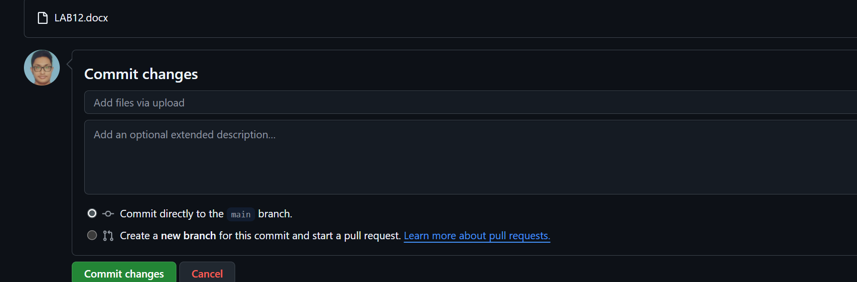
Pull Request
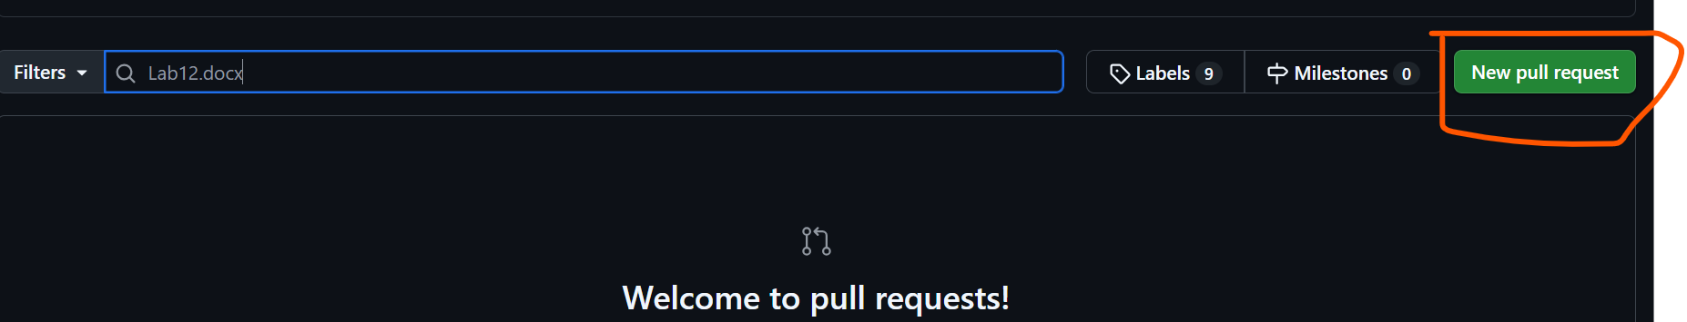
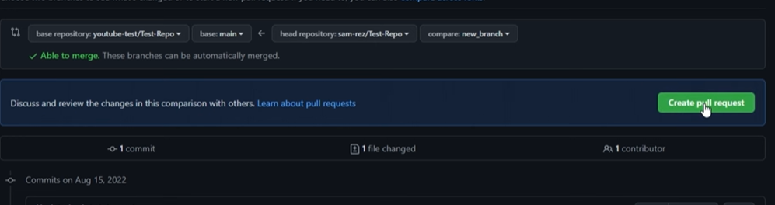
MergeRequest
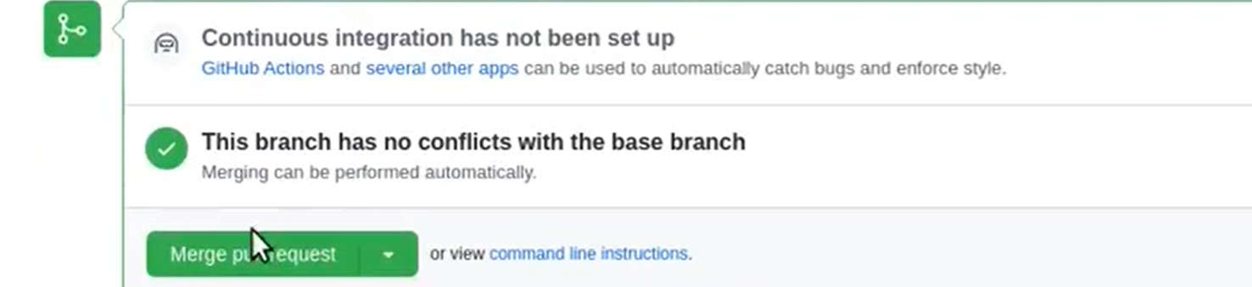
Push
